Subject/Grade Level: Physical Education Grades: 9-12 (15 Day Fitness Project)-See Attached Fitness Circuit Challenge Chart for list of exercises. Students who are on Medical will do the written part ONLY.

Key component, skill, or concept  Students will be able to:  Personal Health and Fitness:  - Students will participate in a variety of aerobic and muscular fitness activities outside of the regular school day. i.e. “15-day fitness challenge” designed by the Physical Education Dept.  - Vocabulary Focus:  - Cardiovascular Endurance  - Muscular Strength/Endurance  - Flexibility  - Body Composition  - Aerobic Vs Anerobic Exercise  - Speed  - Agility  - Cool down/warm up  - Nutrition  - Identify Major Muscle Groups | Measurable activity – output  During a (15 Day) 3 Week Fitness Challenge students will:  - Be physically active for at least 20-30 minutes per day for a minimum of 15 days. Track my activity using the activity log provided in this journal.  - Participate in a variety of aerobic/Anerobic and muscular fitness activities outside of the regular school day assigned by their Phys. Ed Teacher and complete a self- assessment.  - Students will record/keep a journal of all the activities they performed and answer the following prompts.  At the end of each week students will:  - In their own words, Students will describe in their journal in Weeks 1-3:  - What do you know about your health and fitness Level?  - What is the difference between Aerobic and anerobic exercises?  - How do you feel before and after exercise?  - The importance of a warm -up and cool down.  - Describe and define the listed Vocabulary terms. Identify Major Muscle Groups.  - How does Nutrition affect your well- being and fitness level? Students will keep a log of their diet by week throughout this project.
A safe and Healthy Environment:  - 1. Students will demonstrate responsible personal and social behavior while engaged in physical activity. They will understand that physical activity provides the opportunity for enjoyment, challenge, self-expression, and communication. Students will be able to identify safety hazards and react effectively to ensure a safe and positive experience for all participants.  Student Management of available resources:  - Students will be aware of and able to access opportunities available to them within their community to engage in physical activity. They will be able to evaluate facilities and programs. Students will also be aware of some career options in the field of physical fitness and sports. | During the 15-day fitness challenge: At the End of the program students will be able to:  - Write a list of 3 things you can do to help your mind and body relax.  - Understand the dangers of overexertion, hypothermia, and heat exhaustion in outdoor activities, with some preventive measures and first aid treatments for each  - Write 5 positive words or phrases you can use today and send to a friend or relative.  - Write 1 sentence that you could use to convince a friend or family member to be physically active with you.  Measurable Activity-Output:  During the 15-day fitness challenge Students Will:  - Identify community programs, such as YMCA/YWCA, Boys/Girls Clubs, Sport Camps, Youth Sports Leagues.  - Identify community facilities for recreational activities, such as parks, swimming pools, and skating rinks.  - Write a Brief explanation of how the Covid-19 Pandemic affected the use of community resources and programs. Include how you think it will be like going forward with suggestions on how to make places safe for the community.

Riverside HS Phys. Ed. Summer Project
Name: _____________________________ Teacher:__________________________
15 Day Full Circuit Challenge

The is a 15-day (3 weeks) “The Foundation Light” is a low impact 100% bodyweight based fitness program. It is also perfect as bodyweight training introduction and getting in sync with your body. All routines are 100% bodyweight based, they include cardio and strength days as well as stretching and some light martial arts elements. This program does not contain any high impact exercise, lunges, or planks in any form - everything is done standing up with low or no pressure on the joints. It will be perfectly suitable for rehabilitation as well as a general fitness journey starting point. Each day is designed as a full circuit routine that is completed with or without rest, depending on your fitness level. YOU control the difficulty by increasing or decreasing your pace as you go from exercise to exercise. You will complete 15 days or 3 weeks. (not 30 days). REMEMBER: You may alter the amount of sets and or levels according to your ability. You do not have to exercise every day.
- **If at any time you are not feeling well stop exercising**
- **If you are not medically able to complete this program, You my skip Part 1. Please complete Part 2 and Part 3 only.
Student Fitness Journal-Please complete questions below
Part 1-Physical Fitness 15 Day Circuit Challenge (3 Weeks Total): See attached workout chart and select from those exercises.
Week Ending On: Week 1_____ Week 2_____ Week 3_____
(If you are not able to do the physical fitness part due to a medical reason skip this part and complete part 2 and Part 3 (the muscle chart). All answers can be done a separate sheet of paper

- How many days this week did you exercise? List all exercises completed.
  - How many Days did you work-out this week? __________
  - List exercises completed

- What do you know about your health and fitness Level as of today?

- How do you feel before and after exercise?

- Do you think you would continue a workout routine after the 15 days are over? Explain.

- After the 15-day Circuit is completed, do you think your fitness level improved or stayed the same? Explain.
Name: ____________________________ Teacher: ______________________

Part 2-Short Response Questions for ALL students to complete: Answers Can be completed on this form or on a separate sheet of paper.
- Vocabulary Focus- Define:

  - Cardiovascular Endurance-

  - Muscular Strength and Endurance-

  - Flexibility-

  - Body Composition-

  - Aerobic Vs Anerobic Exercise- (Explain the difference)

  - Speed-

  - Agility-

  - Cool Down/Warm UP-

  - Nutrition-

  - Major Muscle Groups-Part 3 (See Diagram).

- Write a list of 3 things you can do to help your mind and body relax.

- Write 5 positive words or phrases you can use today and send to a friend or relative.

- Write at least 1 sentence that you could use to convince a friend or family member to be physically active with you.

- What community resources and programs are available to you to stay fit during the summer?

- How can Nutrition and or diet affect your fitness level?

Part 3-Muscular System (Upper Body)- (You may have to do some research for this one)

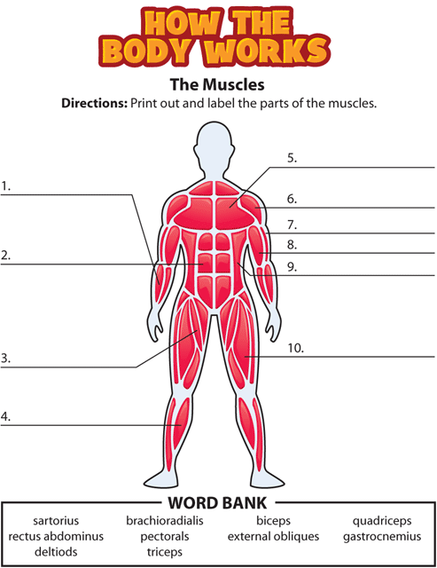
** If you are unable to print this out you can write your answers on a separate sheet of paper. Write the name of the muscle and put the number next to it. See example below

Sartorius Muscle: #____ Brachioradialis: #____ Biceps: #____

Rectus Abdominus: #____ Pectoralis: #____ External Oblique: #____

Deltoid Muscle: #_____ Triceps: #____ Quadriceps: #____

Gastrocnemius: #____

